In your recently published paper in SM, the following equation is used to fit the forward characteristics of Si solar cells,

$$J\left(V,T\right)=-J_{Ph}+\frac{qn_{i}d}{2τ_{g}}\left\{\exp\left[\frac{q\left(V-JR_{s}\right)}{n_{id}kT}\right]-1\right\}+\frac{qn_{i}^{2}}{p_{p}}\sqrt{\frac{μ_{n}kT}{τ_{n}}}\left\{\exp\left[\frac{q\left(V-JR_{s}\right)}{kT}\right]-1\right\}+\frac{V-JR_{s}}{R_{sh}} (1)$$

Please note that above equation has the following problem,

In the exponential term of above equation the product JRShas the dimension of Volt/cm2 where as V is in Volt. This means that JRS can’t be subtracted from V. Fitting of the forward J-V characteristics with the above equation is going toyieldincorrectresults.

**The Rs has the dimension of Ohm⋅cm2(the series resistanceis “area−related”)– see OPTO−ELECTRONICS REVIEW 21(3), 259–282, DOI: 10.2478/s11772−013−0095−5.**

**The equation (1) is not equal to eq. (1) in SM: the third item does not depend on idealityfactornid.**

It is fine if you are using series resistance with dimensions of Ohm-cm2. In my formulation (eq.3) the series resistance is in Ohms.

You are right that third term in eq.(1) in SM paper is independent of ideality factor. I have now made this correction in equation (1) above.

Alternatively I have tried to fit the experimental data (I-V characteristics in place of J-V characteristics) received from you with the following equation,

$$I=-I_{Ph}+I_{sat}\left[\exp\left(\frac{qV}{ηkT}\right)-1\right] (2)$$

In the above equation η is the ideality factor. While fitting the forward characteristics the series resistance of the diode is taken care of by using the following expression,

$V_{appl}=V+I{. R}_{s}$ (3)

Where Vappl is the externally applied voltage, V is the voltage across junction and Rs is the series resistance of the diode in Ohms.

Figure 1 shows dark I-V characteristic of sample t1 at 291K. Circles exhibit the experimental data and continuous line is the theoretical fit by equations (2) and (3). Measured dark characteristics are however not absolutely dark characteristics as the diode current has a finite value at zero bias. The experimental data exhibits a current value of 1.90e-10 Amps at reverse bias voltage of -2.10e-5 volts. By assuming the current value of 1.9e-10 amps as the photocurrent the fit shown in Figure 1 was obtained for an open circuit voltage of 1.5e-6 volts.

**The values 2.10e-5 volts and 1.9e-10 amps are very close to measurement error of experimental setup setup.**

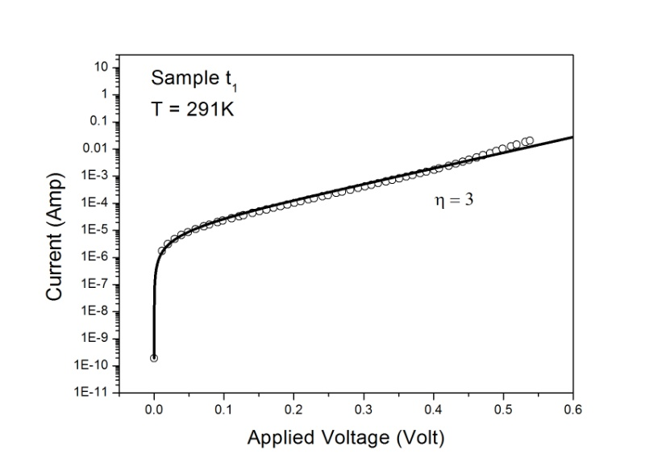Figure 1: Forward I-V ofsample t1.

The results obtained for sample S1 are shown in Figure 2. These illuminated I-V characteristics were measured at 291K under low illumination of 600 nm monochromatic radiation. Circles exhibit the measured data and continuous lines correspond to theoretical fit using equations (2) and (3). The measured current of 1.713e-5 amps at -5.4e-5 volt was assumed as the photocurrent of the diode. The continuous line fit as shown in Figure 2 was obtained for a VOC of 8.1e-2 volt and ideality factor of 3.

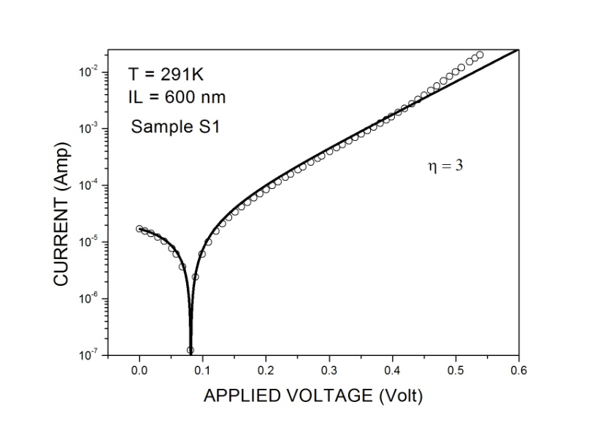Figure 2: Forward I-V of sample S1.

Figure 3 shows similar results for sample L1. The measured illuminated forward I-V at 291K under low illumination of 900 nm monochromatic radiation are shown by points (circles) in Figure 3. Continuous lines exhibit the theoretical fit of the measured data by equations (2) and (3). The measured current of 1.893e-4 amps at -4.30e-4 volts was assumed as the photocurrent of the diode. The continuous line fit shown in Figure 3 was obtained for a VOC of 2.42e-1 volt and ideality factor of 3.

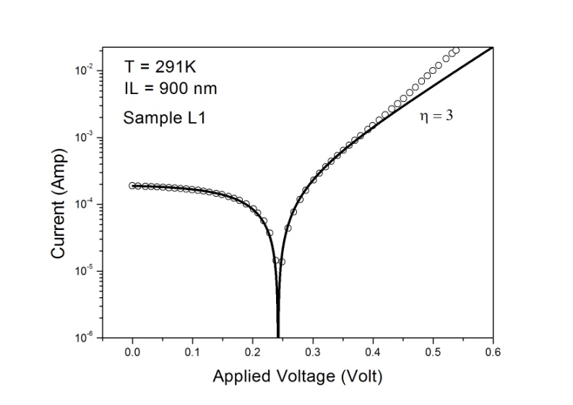Figure 3: Forward I-V of sample L1

Similar kind of fitting between the experimental data and theory is obtained for higher temperatures as well.

The purpose of the above write up is to point out the problem in using equation (1) to fit the experimental forward I-V characteristics of solar cells in your paper. In addition my analysis of the data show that the experimental data provided by you can be fittedwith a I have also noted that the shunt resistance of these solar cells is around 3000 to 6000 ohms. This kind of low shunt resistance may be due to the presence of high surface leakage currents that is responsible for the high ideality factor of 3 of the Si diode in the present case. Our gate controlled diode experiment in HgCdTe has already shown (J. Appl. Phys. 120: 8, 084508 (2016)) the dependence of ideality factor on surface leakage currents.

**The using of much simpler combination of equations (2) and (3) leads to considerable divergence between fitted curve and experimental data at high bias. The results on fitting two exponent items are shown in below figure. The extracted value of ideality factor is equal to ≈2.80 in the both case. Besides, I can to obtain information about recombination in the quasi-neutral region (Isat2 or jsat2).**

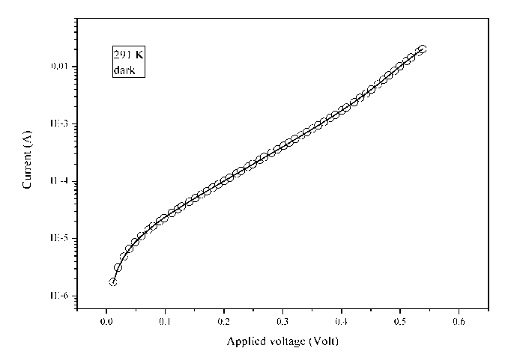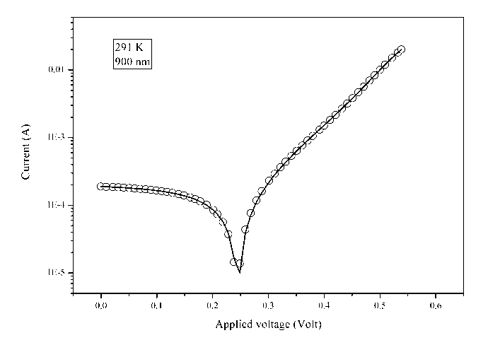

Whatever has been shown above looks fine. However I have carried out an additional exercise with your data and the results of this exercise are given below.

Figure N1 shows the fit of I-V characteristic of the solar cell to equations (2) and (3) at a temperature of 315.5K for three different illuminations by varying the photocurrent Iph generated respectively at each illumination level. For dark characteristic t8 the photocurrent Iph is zero. For 600 nm illumination I-V characteristic marked S8 Iph is 1.63E-5 amp. Similarly Iph is 1.99E-4 for illumination level L8. The open circuit voltage VOC of 8.1E-2 volt corresponding to S8 illumination level was used to estimate Isat. The temperature T is constant for all the three illuminations, the values of ƞ and Isat are also same for all the three illumination levels.

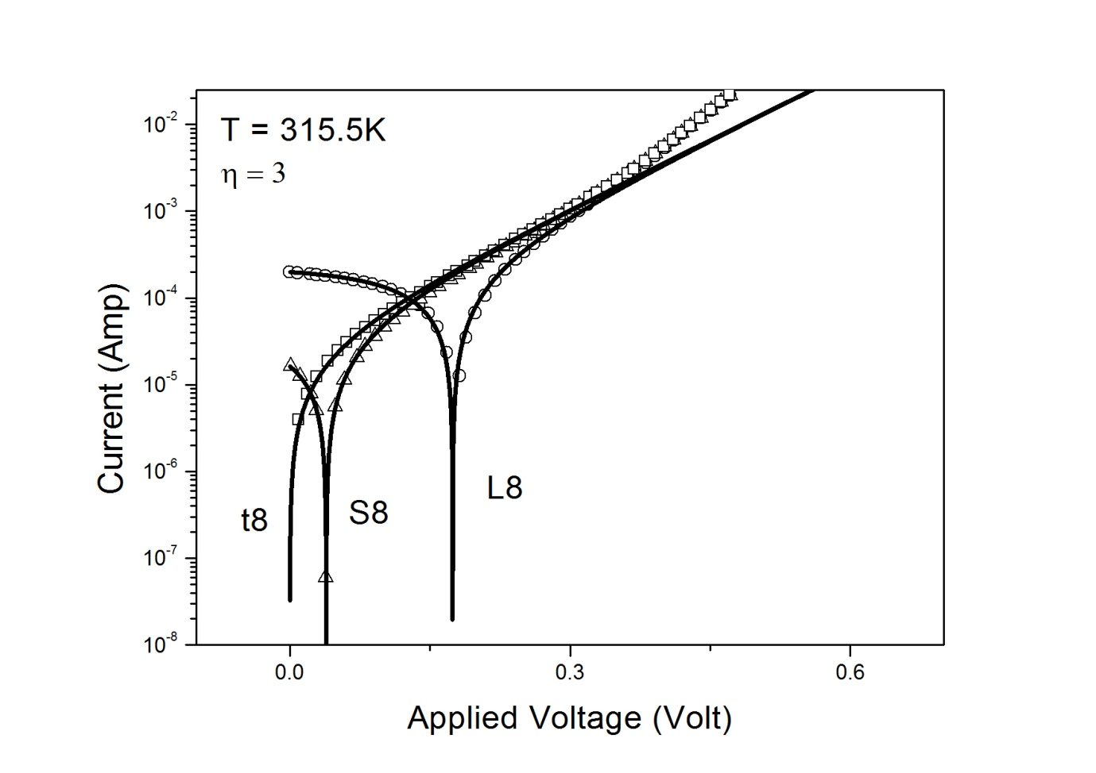

Figure N1: Discrete points are the experimental data and continuous lines were theoretically generated by using equations (2) and (3).

.

Continuous lines shown in Figure N1 were generated for a series resistance of 1E-10 ohms. **Note that the divergence of continuous lines from the experimental data is occurring in the higher forward bias voltage region where the diode current is likely to be limited by the series resistance of the diode. In the high forward bias voltage region junction’s own dynamic resistance is smaller and therefore the series resistance is expected to dominate.**

Surprisingly in the present case the measured current (experimental points) is higher than the calculated current (continuous line) based on the series resistance that is required to fit the single term exponential growth of the diode current from zero bias to open circuit voltage in the intermediate forward bias range. It is an unusual observation for me. I have analysed the data of a large number of small area diodes fabricated from HgCdTe and GaSb/InAs based super lattice material. I have been always able to obtain the single exponential fit in the high forward bias region too. Immediately I can not offer an explanation to the observed divergence at high forward bias voltages in these large area solar cells. However my request is that for the time being you can confirm to me that a two term exponential fit can reproduce a figure similar to Figure N1 without divergence at higher forward voltages simply **by varying the photocurrent only** in case of the variable illumination.

I am still not able to believe that one requires two exponential terms to fit the data at high forward bias voltages, where the diode current is expected to be limited by the series resistance. To me it appears that some more work including the understanding of the changes in the reverse bias characteristics of the diode is still required to be carried out. If you are interested and agree to extend your work in this direction I will be happy to collaborate with you.